Please use the style pane settings in Word, as indicated in [brackets] in this template.

Insert your title here [Title style]
Abstract: Place your abstract here. No more than 150 words. For the abstract, use Aptos 12pt font, left aligned, 1.2 line spacing, indented 1cm left and right, 12pt space after the paragraph. [Abstract and keywords]
Keywords: Up to four keywords or focus terms by which your paper can be indexed. [Keywords]

Heading level 1 [Heading 1]
Heading level 1: Aptos 18pt font, bold, left aligned, 1.2 line spacing, 24pt space before and 12pt space after, keep with next.

Heading level 2 [Heading 2]
Heading level 2: Aptos 14pt font, bold and italics, left aligned, 1.12 line spacing, 12pt space before, 6pt space after, keep with next.

Heading level 3 [Heading 3]
Heading level 3: Aptos 12pt font, Bold, left aligned, 1.2 line spacing, 6pt space before, 0pt space after, keep with next. Only use this heading level if necessary.
Fourth level heading not recommended for Early Education Journal.

Body of your paper. Normal style: Aptos 12pt font, left aligned, 1.2 line spacing, 12pt of space after each paragraph. Don’t add an additional line space after each paragraph. Don’t indent the first line of the paragraph. [Body Paragraph]

This is a bulleted list:
- Aptos 12pt font;
- Left aligned, 1.2 line spacing; and
- Left indent 0.63cm, hanging indent 0.63cm. [List paragraph with bullet points]

This is a numbered list:
- Aptos 11pt font, left aligned, 1.2 line spacing;
- Left indent 0.63cm, hanging indent 0.63cm; and
- Use 1., 2., ...; i., ii., ...; or a., b., ... [Numbered list]

Types of Quotes
For indented long quotes (more then XX words), use the [Quote] style. Aptos 12 point, left aligned, 1.2 line spacing, indented 1.0 cm left and right, not italicised, 12pt space after. Do not use quote marks. Referencing for the quotation may be given in the running text immediately before the quotation, or may be appended to the end of the quotation (after the final punctuation mark). In general, very short quotations using only a few words should be given with quote marks in your running text, whilst only longer quotations using 40 words or more should be formatted as indented quotations. (Author, YYYY, p. xx)
For short quotes (less than xx words) use Normal style: Aptos 12pt font, left aligned, 1.2 line spacing, “with quote marks in the body of paragraph” (Author, YYYY, p. xx). 12pt of space after the paragraph.

For Highlight Statements – key points from the body of the text that you want to emphasis. Less than 30 words.

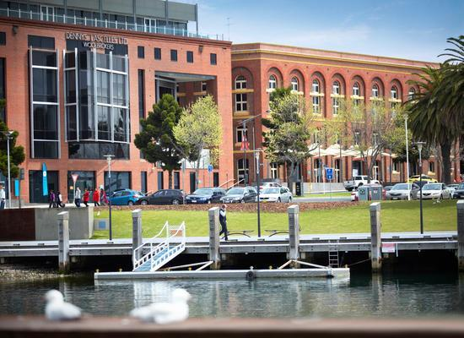
Figure 1. Sample of a figure (caption is below figure) [Figure Caption]
Figures must be placed in their correct location in your running text. All figures should be included in your Word file, and not in separate graphic or drawing package format. Centre the image. For the figure caption, Aptos 12pt font, centre aligned, italics, 1.2 line spacing, 18pt space after. Number sequentially: Figure 1, Figure 2, etc. Do not use variations such as Figure 1a, 1b.
Table 1. A sample table (caption is above table) [Table Caption]
Location | Tables must be placed in their correct, appropriate locations in your running text
General | In general use Aptos 12pt font and other normal style specifications for all text within a table, though 11pt or 10pt may be used as required for narrow columns. Tables should have a title with consecutive numbering (e.g., Table 1. Title of the table), italics, using sentence case, left aligned, and located at the top of the table. For headings within tables use sentence case, with bold and centring optional.
Format | Use 3pt space above and below for each row in the table. Change column widths for the most efficient use of space. In columns of numbers, use centre or decimal point alignment.
Explanatory text | If your table requires explanatory text that is inappropriate for placing in your running text, place it at the bottom of the table, formatted to the same width as the table.
Other features | Cell background colouring or shading may be used, but check that grey scale printing (600 dpi) is not impaired. Leave one line of blank space after the table, before the running text resumes.

References [Heading 1]
Use APA 7th edition style for references. This style prescribes alphabetical order by first author. Use Aptos 12pt font, left aligned, 1.2 line spacing, hanging indent 1cm. 6pt line spacing after each reference, no blank lines between references. Wherever possible, insert DOIs or URLs for references. However, do not insert URLs for publications that only offer pay per view, institutional subscriber, or on campus only access to full text. APA 7 does not require a date of access for references. Use [Bibliography] style.
The following list provides examples of referencing for different types of publications:
Braun, V., & Clarke, V. (2006). Using thematic analysis in psychology. Qualitative Research in Psychology, 3(2), 77–101. https://doi.org/10.1191/1478088706qp063oa
Creswell, J. W., & Plano Clark, V. L. (2011). Designing and conducting mixed methods research (2nd ed.). Sage Publications.
Denzin, N. K. (2002). The interpretive process. In A. M. Huberman & M. B. Miles (Eds.), The qualitative researcher’s companion (pp. 349–366). Sage Publications.
Ministry of Education. (2013). Ka hikitia: Accelerating success 2013–-2017. The Māori education strategy. Ministry of Education. https://assets.education.govt.nz/public/Documents/Ministry/Strategies-and-policies/Ka-Hikitia/KaHikitiaAcceleratingSuccessEnglish.pdf
Smith, L. T. (2012). Decolonizing methodologies: Research and indigenous peoples (2nd ed.). Zed Books.

